End-to-End Telecom Customer Churn, Revenue & Payment Behavior Analysis
Using Python (Pandas) & Power BI

Project Objective
The objective of this project is to analyze customer churn behaviour, revenue generation, payment trends, and plan performance using telecom subscription data.
This project aims to:
- Measure churn rate
- Analyze payment delays
- Determine most profitable plans
- Provide business-driven recommendations
- Understand revenue distribution
- Compare active vs churned customers
- Provide actionable business insights
Business Problem Statement
Telecom companies face the following challenges:
- High customer churn rate
- Revenue leakage due to late or failed payments
- Low plan upgrade conversion
- Poor visibility into payment behaviour patterns
- Difficulty identifying at-risk customers

Tools & Technologies Used
- Python (Pandas, NumPy)
- Power BI (DAX, Data Modeling,KPI)
- Jupyter Notebook
Project architecture
Python (Cleaning & Feature Engineering)
↓
CSV Export
↓
Power BI Data Modeling
↓
DAX Calculations
↓
Interactive Dashboards
↓
Business Insights

Dataset Description:
Customers table – Customer ID, gender, age, Region, Join date, Customer Segments, Tenure months, Device type, Support tickets count (10,000 records).
Payments table – payment Id, Customer ID, Amount, Payment Date, Payment method , Payment Status, Late payment flag (30,000 records).
Plans table – Plan ID, Plan type, Monthly Cost, Data limit GB, Voice limits, SMS limit (3 records).
Subscription table – Subscription ID , Customers ID, Plan ID, Start Date, End Date, Status , Auto renew (10,000 records).

Data Cleaning & Preprocessing ( Python – Pandas ) Using Jupyter Notebook:
Customers Table Data Cleaning (10,000 records) :
import pandas as pd
# Loading Customers(Excel) data
customers = pd.read_excel(r"C:\Users\Ravi Kumar\Downloads\Telecom_jupyter\data\customers.xlsx")
display(customers)

# Identifying Duplicated rows
print("Duplicated Values -",customers.duplicated().sum())

# Cross checking column names,finding null values,improper text,Changing data types,Distinct Values
print(customers.info())

# Found null values & improre data in Age column and those are string
print(customers['age'].unique())

# Correcting
customers['age']=customers['age'].fillna('0')
customers['age'] = customers['age'].replace({
'thirty': '30',
'Twenty three': '23',
'twenty one': '21',
'one eight': '18',
'five five': '55'
})

#Changing Data type of Age column
customers['age']=customers['age'].astype(int)
print(customers.info())

#Filling Customers Age who contains 0 as age with mean value of that column
print(round(customers['age'].mean()))

customers['age']=customers['age'].replace(0,round(customers['age'].mean()))
print(customers['age'].unique())

# Checking Gender column
print(customers['Gender'].unique())

#Correcting Gender data
customers['Gender']=customers['Gender'].replace({
'MALE':'Male',
'FEMALE' :'Female',
'FEmal' :'Female'
})
print(customers['Gender'].unique())

# Checking Region column
print(customers['Region'].unique())

#Correcting Gender data
customers['Region']=customers['Region'].replace({
'NORTH':'North',
'SOUTH' :'South',
'WEST' :'West',
'EAST' :'East'
})
print(customers['Region'].unique())

#Checking Joining date column
print(customers['JoinDate'])

# Format is correct but i have to change data type
customers['JoinDate'] = pd.to_datetime(customers['JoinDate'])
print(customers['JoinDate'])

#Checking CustomerSegment column
print(customers['CustomerSegment'].unique())

#Checking TenureMonths column
print(customers['TenureMonths'].unique())

#Checking DeviceType column
print(customers['DeviceType'].unique())

#Checking SupportTicketsCount column
print(customers['SupportTicketsCount'].unique())

#Cross Checking Table
print(customers.info())
#converting Total cleaned data set into CSV
customers.to_csv("customers_cleaned_final.csv", index=False)

Payments Table Data Cleaning (30,000 records) :
import pandas as pd

#Loading Payments(CSV) data files
payments = pd.read_csv(r"C:\Users\Ravi Kumar\Downloads\Telecom_jupyter\Original data set\payments.csv")
display(payments)

# Checking column names,finding null values,improper text,Changing data types,Distinct Values
print(payments.info())

#Changing data type of PaymentDate
payments['PaymentDate'] = pd.to_datetime(
payments['PaymentDate'],
format='%d-%m-%Y'
)
print(payments['PaymentDate'])

payments.to_csv("payments_cleaned_final.csv", index=False)

Plans Table Data Cleaning (3 records) :
import pandas as pd
# Loading Customers(Excel) data
plans = pd.read_csv(r"C:\Users\Ravi Kumar\Downloads\Telecom_jupyter\Original data set\plans.csv")
display(plans)

# Cross checking column names,finding null values,improper text,Changing data types,Distinct Values
print(plans.info())

Subscriptions Table Data Cleaning (10,000 records) :
import pandas as pd
# Loading Customers(Excel) data
subscriptions = pd.read_csv(r"C:\Users\Ravi Kumar\Downloads\Telecom_jupyter\Original data set\subscriptions.csv")
display(subscriptions)

# Identifying Duplicated rows
print("Duplicated Values -",subscriptions.duplicated().sum())

# Changing data type of StartDate Column
subscriptions['StartDate'] = pd.to_datetime(subscriptions['StartDate'],format='%d-%m-%Y')
print(subscriptions['StartDate'])

# Changing data type of EndDate Column
# No Need to fill null values because only Churned customers will have end dates
subscriptions['EndDate'] = pd.to_datetime(subscriptions['EndDate'],format='%d-%m-%Y')
print(subscriptions['EndDate'])

#converting Total cleaned data set into CSV
subscriptions.to_csv("subscriptions_cleaned_final.csv", index=False)

Data Modeling ( PowerBI )
Relationships Created:
- Customers (1) → Subscription (Many)
- Customers (1) → Payments (Many)
- Plans (1) → Subscription (Many)

Columns :
Age Group = SWITCH(TRUE(),customers[age]<=21, "0-21",
customers[age] <= 28, "22-28",
customers[age] <= 40, "29-40 ",
"40+"
)

Date Tables :
Payment Date Table = ADDCOLUMNS( CALENDAR(MIN(payments[PaymentDate]), MAX( payments[PaymentDate])), "Year", YEAR([Date]), "Month", FORMAT([Date], "MMMM"),
"Month Number", MONTH([Date]))

Subscriptions Date Table = ADDCOLUMNS( CALENDAR(MIN(subscriptions[StartDate]), MAX( subscriptions[StartDate])), "Year", YEAR([Date]), "Month", FORMAT([Date], "MMMM"),
"Month Number", MONTH([Date]))

DAX Measures :
Failed Payments Revenue = CALCULATE(SUM(payments[Amount]),payments[PaymentStatus]="Failed")

Late Payments = CALCULATE(COUNT(payments[PaymentID]), payments[LatePaymentFlag] = 1)

Late Payments% = DIVIDE([Late Payments],COUNTA(payments[PaymentID]))*100

Successful Payments Revenue = CALCULATE(SUM(payments[Amount]),payments[PaymentStatus]="Success")

Total payments = COUNTA(payments[PaymentID])

Total Revenue = SUM(payments[Amount])

Active Subscriptions = CALCULATE(DISTINCTCOUNT(subscriptions[CustomerID]),subscriptions[Status]="Active")

Churned Customers = CALCULATE(DISTINCTCOUNT(subscriptions[CustomerID]),subscriptions[Status]="Churned")

Churned rate% = DIVIDE([Churned Customers],customers[Total Customers])*100

Current year Subscriptions = TOTALYTD([Total Subscriptions],'Subscriptions DTable'[Date])

Previous year subscriptions = CALCULATE([Total Subscriptions],YEAR('Subscriptions DTable'[Date])=YEAR(TODAY())-1)

Profit = [Total Revenue] - [Total Cost]

Total Cost = SUMX(subscriptions,RELATED(plans[MonthlyCost]))

Total Subscriptions = DISTINCTCOUNT(Subscriptions[CustomerID])

Dashboard – 1
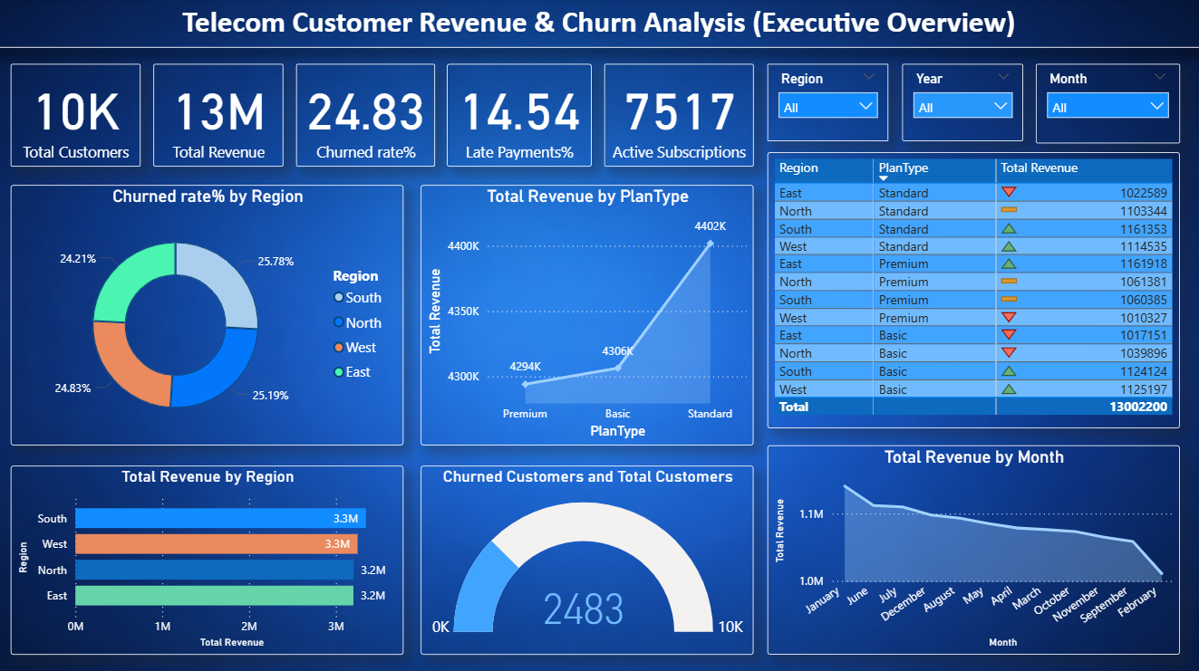

Dashboard – 2
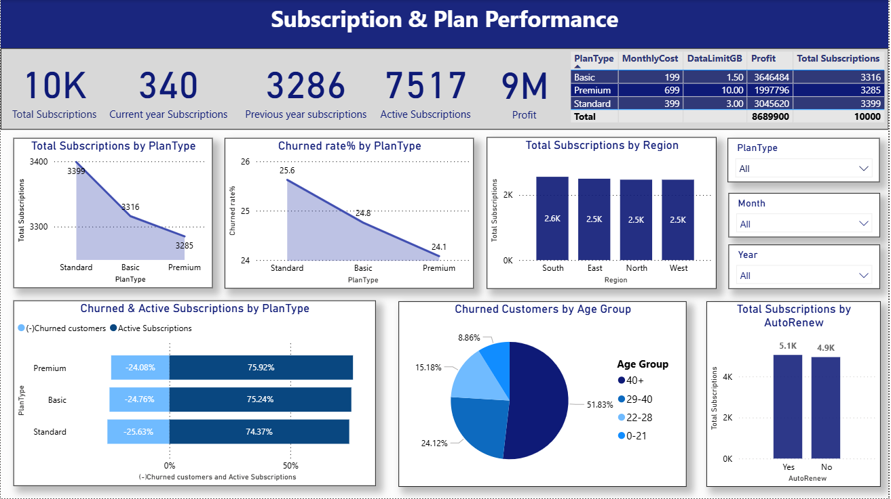

Dashboard – 3
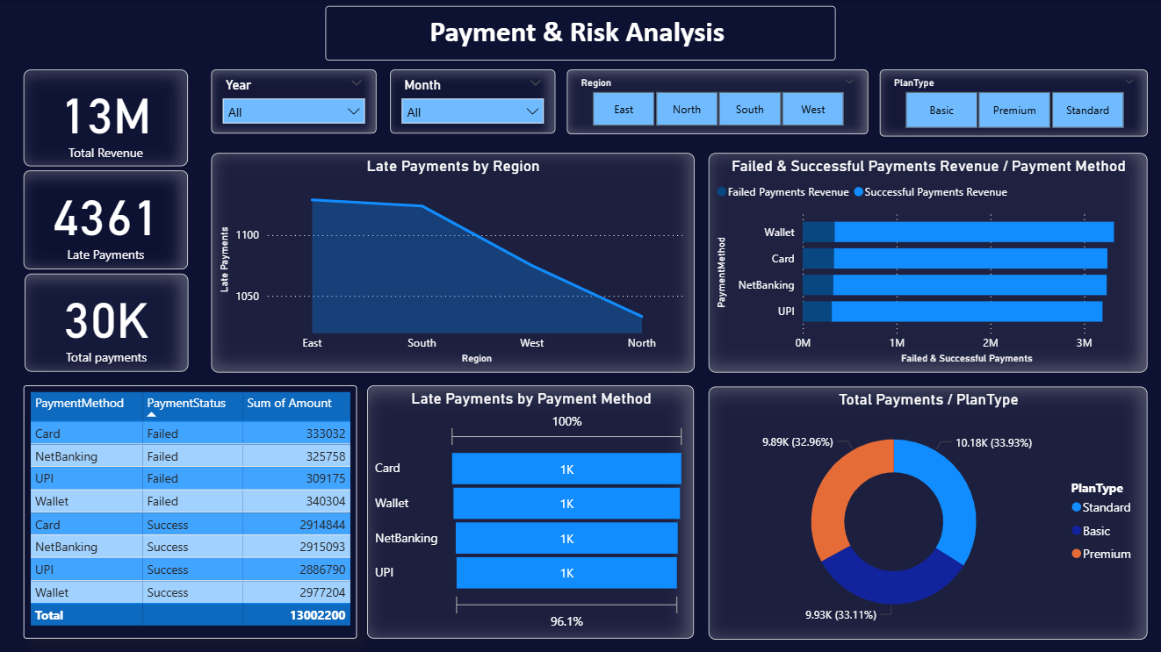

Project impact :
This project enables telecom management to:
- Reduce churn
- Reduce revenue leakage
- Increase customer retention
- Adjust pricing strategy
- Increase profitability
- Launch region-specific campaigns
- Focus expansion in high-performing regions
- Identify which payment mode causes higher failures

Conclusion :
This project analyzes telecom churn, payment behaviour, and revenue performance using four relational datasets. I used Python Pandas for data cleaning and feature engineering, built a star schema model in Power BI, created DAX measures for churn rate, revenue, and late payment analysis, and developed three dashboards focusing on executive insights, churn patterns, and payment analytics.

